**Student API – CRUD Operations with ASP.NET Web API**

**Agenda**

* Angular Application having a Home Page and a Navigation Bar
* Install bootstrap
* Implementing Routes and link to CRUD based Links
* Components
  + **studentList**
  + **addStudent**
  + **studentDetails**
  + **deleteStudent**
* Student List Component
* Add New Student Component
* Student Details Component
* Delete a Student Component
* ASP.NET Core Web API
  + Create a student table in SQL Server
  + Create Web API using ASP.NET Core and entity framework
* Test Web API
* Final Application Execution

**Angular Application having a Home Page and a Navigation Bar**

* In my D drive I created a folder named NGLearn. And now go to terminal/ command prompt and use NG CLI command to create angular application.
* Create a basic Angular Application 🡪 studentCrudDemo

**> ng new studentCrudDemo**

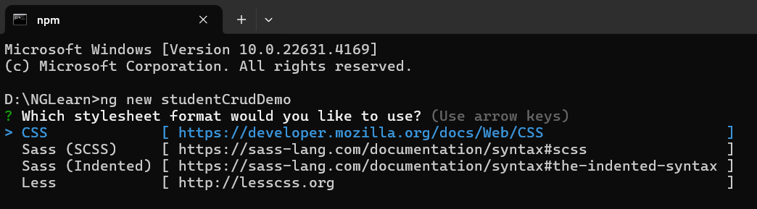

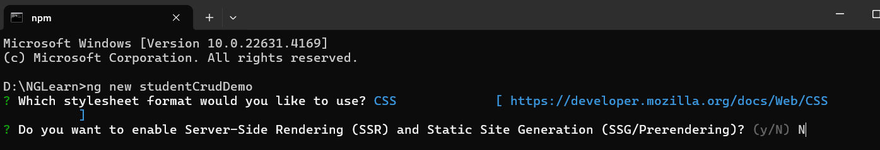

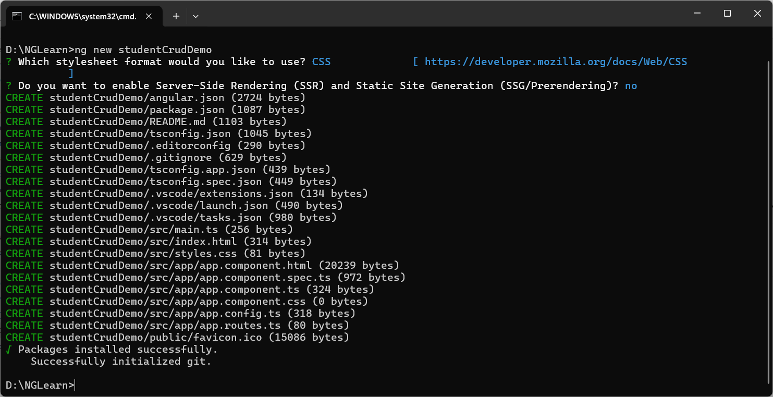

* Exit the CMD and open folder in Visual Studio Code
* Open a terminal window
* Install bootstrap

npm i bootstrap --save

* Add to angular.json file

 "styles": [

              "node_modules/bootstrap/dist/css/bootstrap.css",

              "src/styles.css"

            ],

 "scripts": ["node_modules/bootstrap/dist/js/bootstrap.js"]

* I want that an entire application background should be having a same background color, so added a style in D:\NGLearn\studentCrudDemo\src\styles.css

body {

  background-color: hsl(210, 100%, 85%);

}

* Add pages folder and create following components in pages folder

PS D:\NGLearn\studentCrudDemo\src\app\pages> **ng g c studentList**

PS D:\NGLearn\studentCrudDemo\src\app\pages> **ng g c addStudent**

PS D:\NGLearn\studentCrudDemo\src\app\pages> **ng g c studentDetails**

PS D:\NGLearn\studentCrudDemo\src\app\pages> **ng g c deleteStudent**

* Add routing to application
* In app.component.ts

import { Component } from '@angular/core';

import { RouterLink, RouterOutlet } from '@angular/router';

@Component({

  selector: 'app-root',

  standalone: true,

  imports: [RouterOutlet, RouterLink],

  templateUrl: './app.component.html',

  styleUrl: './app.component.css'

})

export class AppComponent {

  title = 'routedemo';

}

* Go to app.routes.ts

import { Routes } from '@angular/router';

import { StudentListComponent } from './pages/student-list/student-list.component';

import { AddStudentComponent } from './pages/add-student/add-student.component';

import { StudentDetailsComponent } from './pages/student-details/student-details.component';

import { DeleteStudentComponent } from './pages/delete-student/delete-student.component';

export const routes: Routes = [

    {

        path: 'student-list',

        component: StudentListComponent

    },

    {

        path: 'add-student',

        component: AddStudentComponent

    },

    {

        path: 'student-details',

        component: StudentDetailsComponent

    }, {

        path: 'delete-student',

        component: DeleteStudentComponent

    },

];

* Add a bootstrap sample navbar

<nav class="navbar navbar-expand-sm navbar-dark bg-dark">

  <div class="container-fluid">

    <a class="navbar-brand" href="javascript:void(0)">Students</a>

    <button

      class="navbar-toggler"

      type="button"

      data-bs-toggle="collapse"

      data-bs-target="#mynavbar"

    >

      <span class="navbar-toggler-icon"></span>

    </button>

    <div class="collapse navbar-collapse" id="mynavbar">

      <ul class="navbar-nav me-auto">

        <li class="nav-item">

          <a class="nav-link" routerLink="student-list">List</a>

        </li>

        <li class="nav-item">

          <a class="nav-link" routerLink="add-student">AddNew</a>

        </li>

        <li class="nav-item">

          <a class="nav-link" routerLink="student-details">Details</a>

        </li>

        <li class="nav-item">

          <a class="nav-link" routerLink="delete-student">Delete</a>

        </li>

      </ul>

      <form class="d-flex">

        <input class="form-control me-2" type="text" placeholder="Search" />

        <button class="btn btn-primary" type="button">Search</button>

      </form>

    </div>

  </div>

</nav>

<router-outlet />

* Now run application and check that links are working and you can navigate to respective contents

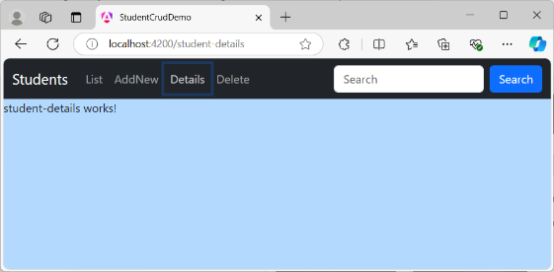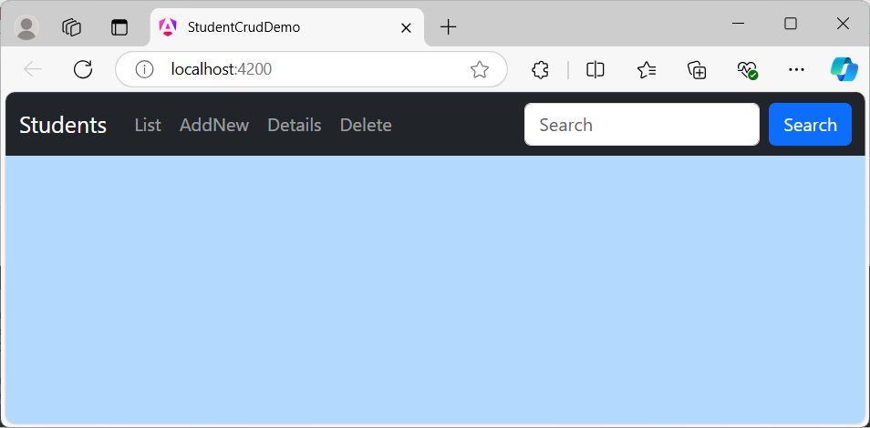

**Student List Component – Get all Student Records from API**

* Here we need to get data from student service.
* Add service folder and add student service in it.

**ng g s student**

* We need to use HttpClient so in app.config.ts add provider

import { ApplicationConfig, provideZoneChangeDetection } from '@angular/core';

import { provideRouter } from '@angular/router';

import { routes } from './app.routes';

import { provideHttpClient } from '@angular/common/http';

export const appConfig: ApplicationConfig = {

  providers: [provideHttpClient(), provideZoneChangeDetection({ eventCoalescing: true }), provideRouter(routes)]

};

* Now create a student service to get student data from API. This API we have generated using ASP.NET Core Web API with SQL Server and Entity Framework. Documentation is available separately check StudentAPI git folder for the same.
* API url is <https://localhost:7088/api/TblStudents> which return JSON as

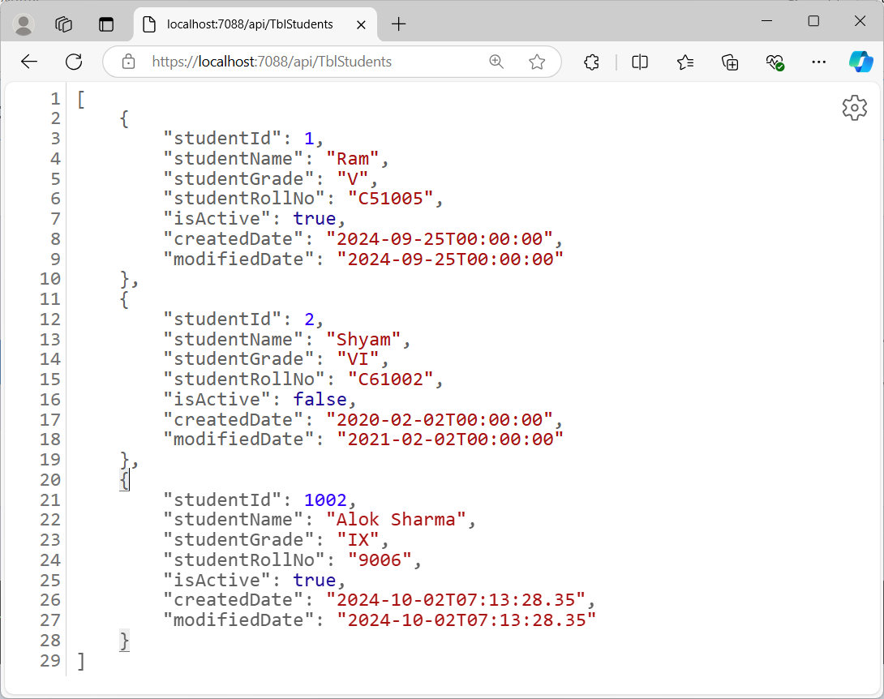

import { HttpClient } from '@angular/common/http';

import { Injectable } from '@angular/core';

@Injectable({

  providedIn: 'root'

})

export class StudentService {

  constructor(private http: HttpClient) { }

  getStudents() {

    return this.http.get("https://localhost:7088/api/TblStudents");

  }

}

* Consume data obtained from API
* Go to student-list-component.ts and modify:

import { Component, inject, OnInit } from '@angular/core';

import { StudentService } from '../../service/student.service';

@Component({

  selector: 'app-student-list',

  standalone: true,

  imports: [],

  templateUrl: './student-list.component.html',

  styleUrl: './student-list.component.css'

})

export class StudentListComponent implements OnInit {

  studentService = inject(StudentService)

  studentList: any[] = [];

  ngOnInit(): void {

    this.loadStudents();

  }

  loadStudents() {

    this.studentService.getStudents().subscribe((res: any) => {

      this.studentList = res;

    })

  }

}

* Now the response obtained from API is collected into studentList array.
* Display studentList array data in HTML file of student-list component.
* Go to student-list.component.html and design as:

<h2>Student List</h2>

<div class="container">

  <div class="row">

    <div class="col-12">

      <table class="table table-borderd">

        <thead>

          <tr>

            <th>Id</th>

            <th>Name</th>

            <th>Grade</th>

            <th>RollNo</th>

            <th>Active</th>

            <th>CreatedDate</th>

            <th>modifiedDate</th>

          </tr>

        </thead>

        <tbody>

          @for (item of studentList; track $index) {

          <tr>

            <td>{{ item.studentId }}</td>

            <td>{{ item.studentName }}</td>

            <td>{{ item.studentGrade }}</td>

            <td>{{ item.studentRollNo }}</td>

            <td>{{ item.isActive }}</td>

            <td>{{ item.createdDate }}</td>

            <td>{{ item.modifiedDate }}</td>

          </tr>

          }

        </tbody>

      </table>

    </div>

  </div>

</div>

* Test it in browser:

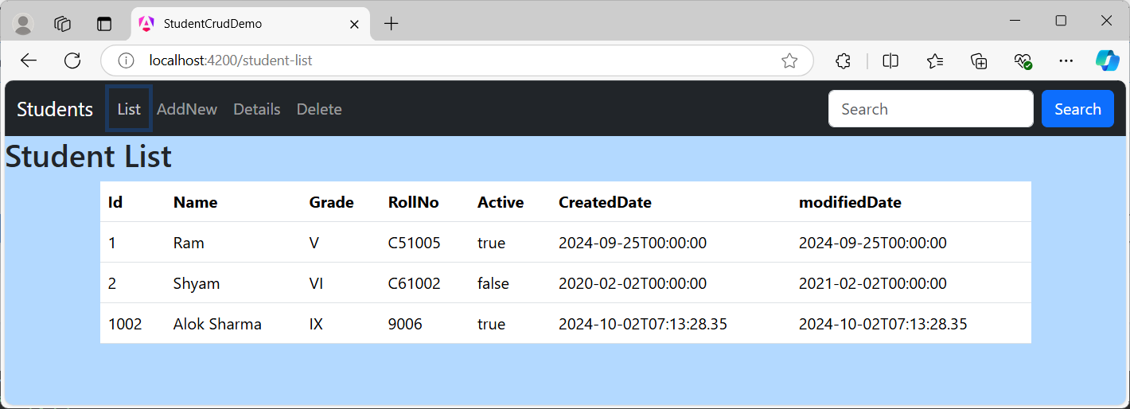

**Add-Student Component – Add New Student Records using API**

* To add a new student record, we need to use a data entry form and need to post student object data to Web API. Api’s post method make arrangement to store data in SQL Server database table. (Your API should be CORS enabled.)
* As in my API following is the POST section

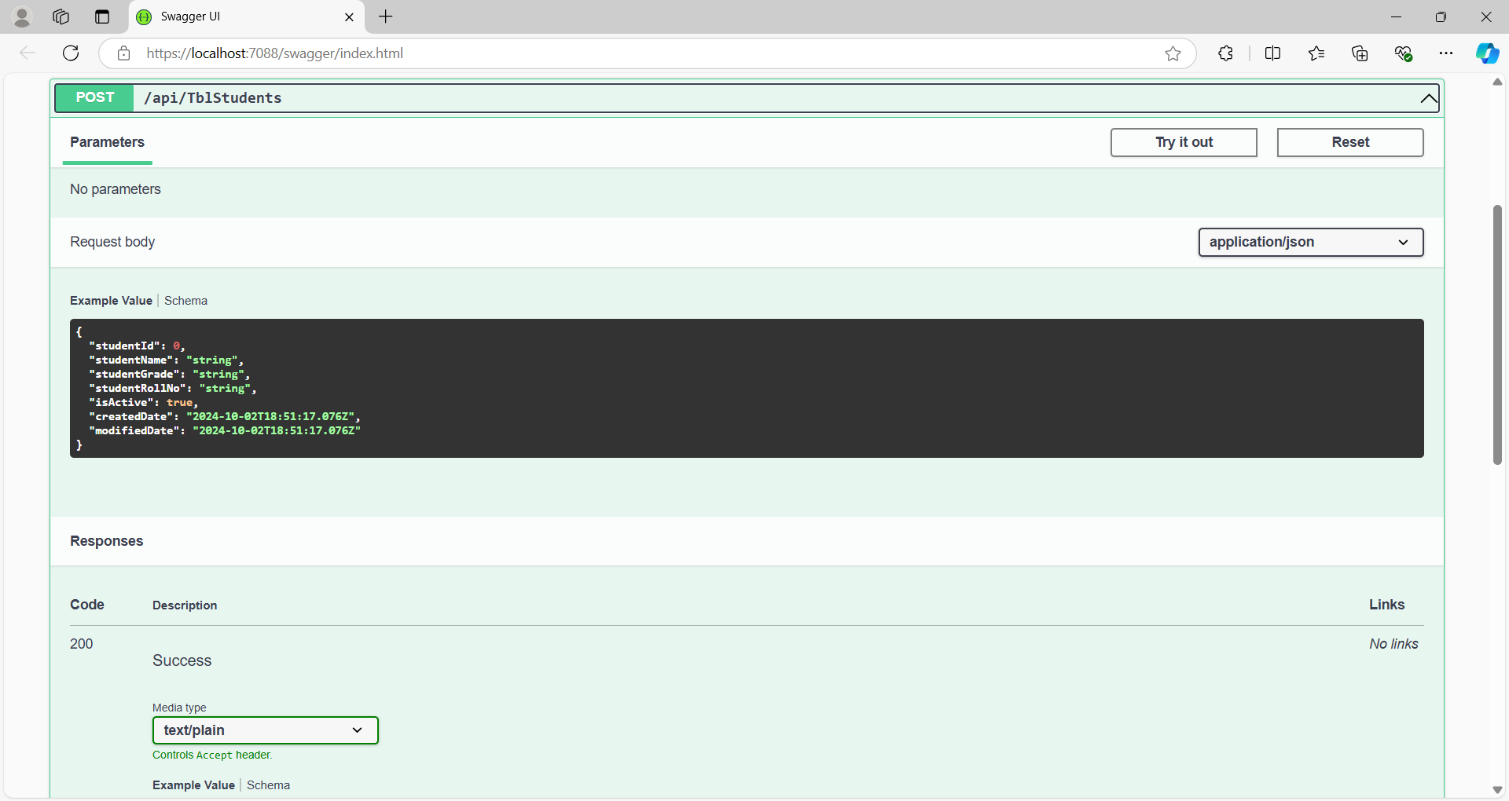

* Here if you try is out then you are allowed to add data by defining data items in JSON object

{

"studentId": 0,

"studentName": "string",

"studentGrade": "string",

"studentRollNo": "string",

"isActive": true,

"createdDate": "2024-10-02T18:51:17.076Z",

"modifiedDate": "2024-10-02T18:51:17.076Z"

}

* Same we will be using in our Angular component to send object with data in add-student component.
* First create a Template Form to Add New Student
* While creating form we will not send StudentId as it is defined a primary key as well identity column. Autogenerated ID will be assigned to newly added record.
* In HTML below I commented the div for studentId as we are not submitting it.
* Go to add-student.component.html and design form as:

<h2>Add New Student</h2>

<div class="form-container">

  <div class="form-header text-center">

    <h2>Student Form</h2>

  </div>

  <form id="studentForm">

    <!-- <div class="form-group">

      <label for="studentId">Student ID:</label>

      <input type="number" class="form-control" id="studentId" name="studentId"

        Required />

    </div> -->

    <div class="form-group">

      <label for="studentName">Student Name:</label>

      <input

        type="text"

        [(ngModel)]="studentObj.studentName"

        class="form-control"

        id="studentName"

        name="studentName"

        required

      />

    </div>

    <div class="form-group">

      <label for="studentGrade">Student Grade:</label>

      <input

        type="text"

        [(ngModel)]="studentObj.studentGrade"

        class="form-control"

        id="studentGrade"

        name="studentGrade"

        required

      />

    </div>

    <div class="form-group">

      <label for="studentRollNo">Student Roll No:</label>

      <input

        type="text"

        [(ngModel)]="studentObj.studentRollNo"

        class="form-control"

        id="studentRollNo"

        name="studentRollNo"

        required

      />

    </div>

    <div class="form-group form-check">

      <input

        type="checkbox"

        [(ngModel)]="studentObj.isActive"

        class="form-check-input"

        id="isActive"

        name="isActive"

        checked

      />

      <label class="form-check-label" for="isActive">Is Active</label>

    </div>

    <div class="form-group">

      <label for="createdDate">Created Date:</label>

      <input

        type="date"

        [(ngModel)]="studentObj.createdDate"

        class="form-control"

        id="createdDate"

        name="createdDate"

        required

      />

    </div>

    <div class="form-group">

      <label for="modifiedDate">Modified Date:</label>

      <input

        type="date"

        [(ngModel)]="studentObj.modifiedDate"

        class="form-control"

        id="modifiedDate"

        name="modifiedDate"

      />

    </div>

    <button

      type="submit"

      class="btn btn-primary btn-block"

      (click)="onSubmit()"

    >

      Submit

    </button>

  </form>

</div>

* Go to add-student.component.ts and add the object in class
* Inject HttpClient
* Create onSubmit()

import { HttpClient } from '@angular/common/http';

import { Component, inject } from '@angular/core';

import { FormsModule } from '@angular/forms';

@Component({

  selector: 'app-add-student',

  standalone: true,

  imports: [FormsModule],

  templateUrl: './add-student.component.html',

  styleUrl: './add-student.component.css'

})

export class AddStudentComponent {

  studentObj: any = {

    "studentId": 0,

    "studentName": "",

    "studentGrade": "",

    "studentRollNo": "",

    "isActive": true,

    "createdDate": "",

    "modifiedDate": ""

  }

  http = inject(HttpClient);

  onSubmit() {

    debugger;

    this.http.post("https://localhost:7088/api/TblStudents", this.studentObj).subscribe((res: any) => {

      debugger;

      if (res.studentId >= 0)

        alert("Student Record Created!");

      else {

        alert("Some Problem in Student Creation")

      }

    })

  }

}

Run the app and go to AddNew link and fill record and submit as:

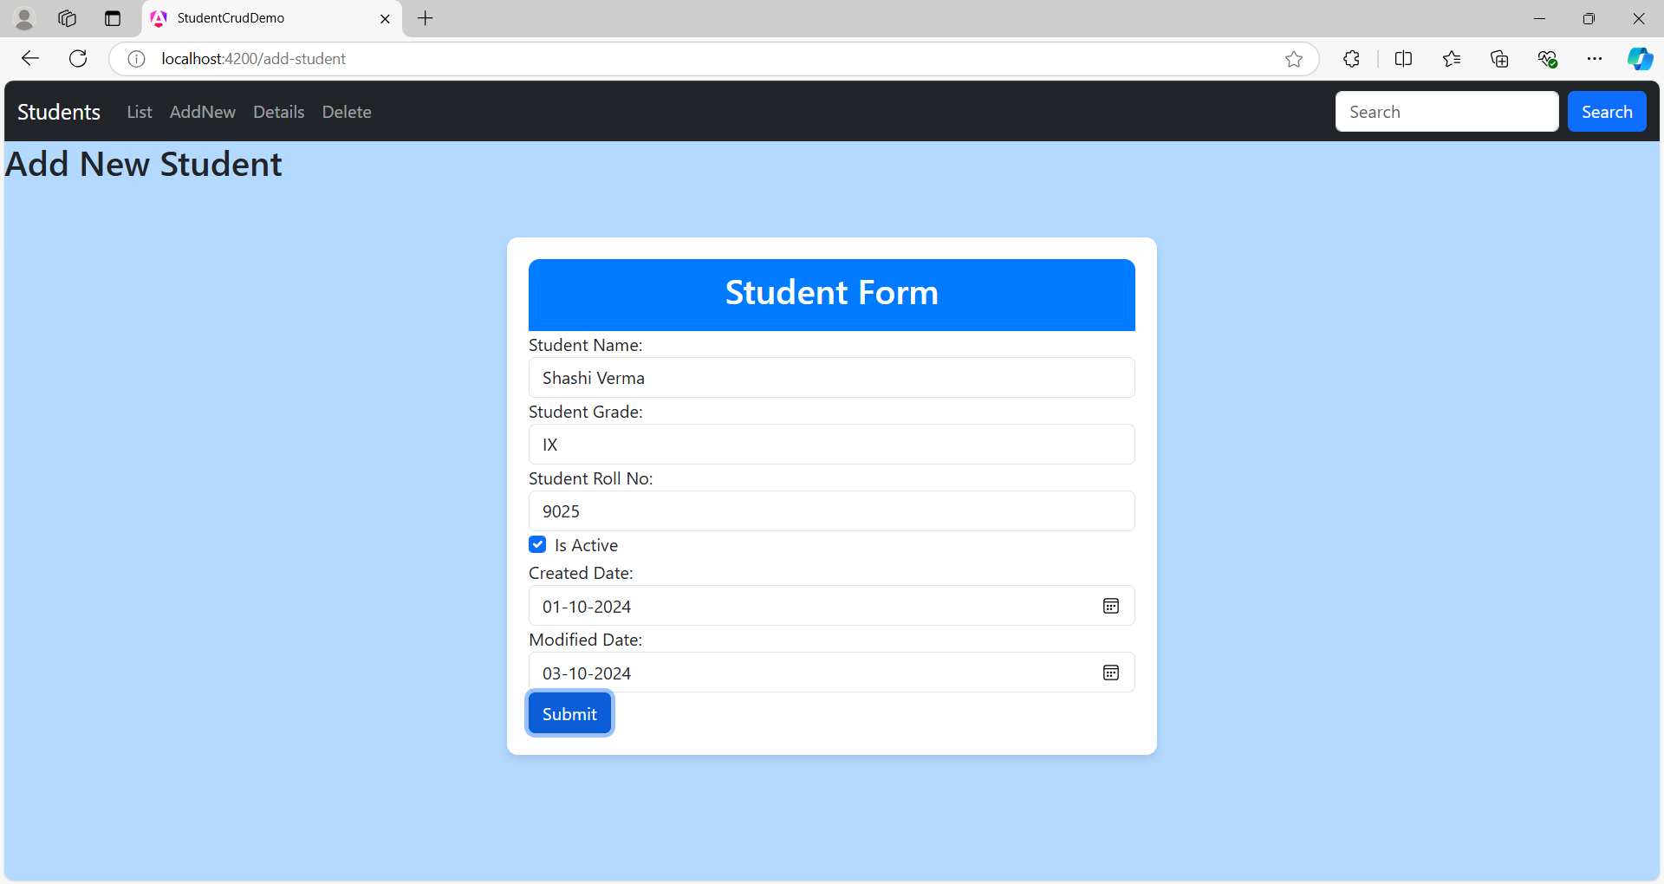

* Check by clicking student-list

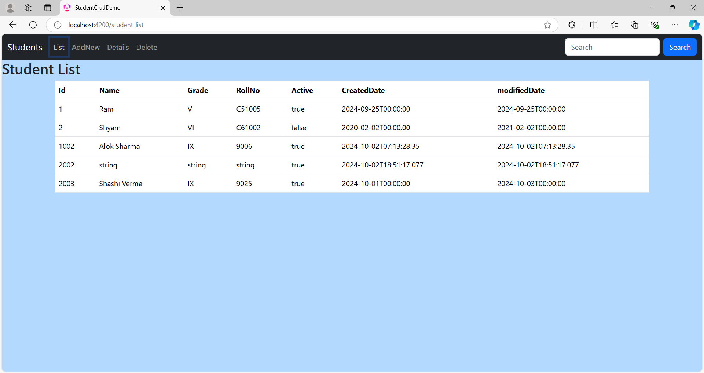

☸✠End of Chapter✠☸